MANUAL HYPERPARAMETER SELECTION FORM
2D CNN Model — Dogs vs. Cats Image Classification
Name: ROMNICK M. CARLOS
Program: DIT 1
Use this form to record, justify, and approve each hyperparameter value chosen by hand before a training run. The "Notebook Default" column shows the value currently used in Loading_Dataset_and_CNN.ipynb for reference — enter the value actually used for this run under "Chosen Value", even if it matches the default.

1. Project / Experiment Information
Project / Experiment Title | CNN Activity w/ hyperparameters tuning
Model Architecture | 2D Convolutional Neural Network (Conv2D)
Dataset Used | Kaggle Dogs vs. Cats images (Dog/ and Cat/ folders)
Notebook / File Reference | Loading_Dataset_and_CNN_optimized.ipynb (Trials 1–4); Loading_Dataset_and_CNN.ipynb (Trial 5)
Prepared By | ROMNICK M. CARLOS
Date | 9/26/2026 - 10/6/2026
Experiment / Trial No. | 1 (manual, 5 epochs), 2 (Keras Tuner), 3 (manual, 20 epochs), 4 (Keras Tuner, second search) and 5 (manual, 20 epochs)

2. Data Preprocessing Parameters
Hyperparameter | Options / Range Considered | Notebook Default | Chosen Value | Justification
Image Size (IMG_SIZE, square) | e.g. 50 / 80 / 100 / 128 / 150 | 100 | 100 | I used less than 100 but blurred
Color Mode | Grayscale / RGB | Grayscale | Grayscale | Grayscale keeps the input to one channel (100 × 100 × 1), which keeps the model small and fast to train on Colab. Colour was not tested in these trials.
Pixel Normalization | X/255.0 / none | X/255.0 | X/255.0 | Dividing the pixel values (0–255) by 255 puts the inputs in the 0–1 range, which helps the network train faster and more stably.
Shuffle Training Data | Yes / No | Yes (random.shuffle) | Yes | Images are loaded one class at a time (all dogs, then all cats). Shuffling mixes the classes before the split; without it the validation set would contain only one class.
Held-out Test Set (separate from training) | Yes / No | No (validation_split only) | No (a 15% test split is created but never used – see Remarks) | A 15% test split is created in the notebook but never evaluated, and later steps split the full dataset again, so the test images also appear in training. Results are therefore reported on the validation set only.
Validation Split (of training set) | 0.0 - 0.3 | 0.1 | 0.2 | 20% of the 24,997 images are kept for validation and 80% for training, which leaves about 5,000 images to measure accuracy on unseen data. Manual trials use the last 20% of the shuffled data; the tuner trials use a stratified 20% split.

3. Model Architecture Hyperparameters
Trial 1
Hyperparameter | Options / Range Considered | Notebook Default | Chosen Value | Justification | Training Accuracy | Validation Accuracy
Conv2D Layer 1 – Filters | 16 / 32 / 64 / 128 | 16 | 32 | A small number of filters is enough to pick up simple edges and textures, and keeps the model small (134,817 parameters in total). | 0.8141 | 0.8152
Conv2D Layer 1 – Kernel Size | (3,3) / (5,5) | (3,3) | (3,3) | 3×3 is the standard small kernel; stacked layers still cover a wide area while using few parameters. | 0.8141 | 0.8152
Conv2D Layer 1 – Activation | relu / tanh / elu / leaky_relu | relu | relu | ReLU is the standard activation for convolution layers; it is fast and avoids vanishing gradients. | 0.8141 | 0.8152
Pooling Layer 1 – Type & Pool Size | MaxPooling2D / AveragePooling2D; (2,2) / (3,3) | MaxPooling2D, (2,2) | MaxPooling2D, (2,2) | 2×2 max pooling halves the feature-map size after each block, reducing computation and keeping the strongest responses. | 0.8141 | 0.8152
Conv2D Layer 2 – Filters | 16 / 32 / 64 / 128 | 16 | 32 | Kept at the same width as the first layer; the filter count is only increased in the deeper layers. | 0.8141 | 0.8152
Conv2D Layer 2 – Kernel Size | (3,3) / (5,5) | (3,3) | (3,3) | Same small kernel as layer 1. | 0.8141 | 0.8152
Conv2D Layer 2 – Activation | relu / tanh / elu / leaky_relu | relu | relu | Same activation as layer 1. | 0.8141 | 0.8152
Pooling Layer 2 – Type & Pool Size | MaxPooling2D / AveragePooling2D; (2,2) / (3,3) | MaxPooling2D, (2,2) | MaxPooling2D, (2,2) | Same pooling as layer 1. | 0.8141 | 0.8152
Conv2D Layer 3 – Filters | 16 / 32 / 64 / 128 | 16 | 64 | Deeper layers combine edges into larger shapes (ears, snouts), so the width is doubled to 64. | 0.8141 | 0.8152
Conv2D Layer 3 – Kernel Size | (3,3) / (5,5) | (3,3) | (3,3) | Same small kernel as layer 1. | 0.8141 | 0.8152
Conv2D Layer 3 – Activation | relu / tanh / elu / leaky_relu | relu | relu | Same activation as layer 1. | 0.8141 | 0.8152
Pooling Layer 4 – Type & Pool Size | MaxPooling2D / AveragePooling2D; (2,2) / (3,3) | MaxPooling2D, (2,2) | MaxPooling2D, (2,2) | Same pooling as layer 1. | 0.8141 | 0.8152
Conv2D Layer 4 – Filters | 16 / 32 / 64 / 128 | 16 | 64 | A fourth conv layer was added to the original three to capture higher-level shapes; width kept at 64 so the model stays small. | 0.8141 | 0.8152
Conv2D Layer 4 – Kernel Size | (3,3) / (5,5) | (3,3) | (3,3) | Same small kernel as layer 1. | 0.8141 | 0.8152
Conv2D Layer 4 – Activation | relu / tanh / elu / leaky_relu | relu | relu | Same activation as layer 1. | 0.8141 | 0.8152
Pooling Layer 4 – Type & Pool Size | MaxPooling2D / AveragePooling2D; (2,2) / (3,3) | MaxPooling2D, (2,2) | MaxPooling2D, (2,2) | Same pooling as layer 1. | 0.8141 | 0.8152
Dense (Fully Connected) Units | 16 / 32 / 64 / 128 | 64 | 64 | Two dense layers of 64 units combine the extracted features for the final decision; 64 is enough for a two-class problem without adding many parameters. | 0.8141 | 0.8152
Dropout Rate | 0.0 - 0.5 | None (not used) | 0.3 | Dropout of 0.3 (after Flatten and after the first dense layer) switches off 30% of units at random during training to reduce overfitting. | 0.8141 | 0.8152
Output Layer Activation | sigmoid (binary) / softmax (multi-class) | sigmoid | sigmoid | One sigmoid unit gives the probability of Cat (Dog = 0, Cat = 1) for this two-class problem and pairs with binary cross-entropy. | 0.8141 | 0.8152
Trial 2 – Keras Tuner best trial (final model)
Hyperparameter | Options / Range Considered | Notebook Default | Chosen Value | Justification | Training Accuracy | Validation Accuracy
Conv2D Layer 1 – Filters | 32 – 256 (step 32) | 16 | 32 | Best trial (#0019) of the Keras Tuner Hyperband search; the tuner also chose 4 conv blocks (searched 2–4). | 0.8795 | 0.8668
Conv2D Layer 1 – Kernel Size | (3,3) / (5,5) | (3,3) | (5,5) | Tuner choice. | 0.8795 | 0.8668
Conv2D Layer 1 – Activation | relu / tanh / elu / leaky_relu | relu | relu | Fixed (not tuned). | 0.8795 | 0.8668
Pooling Layer 1 – Type & Pool Size | MaxPooling2D / AveragePooling2D; (2,2) / (3,3) | MaxPooling2D, (2,2) | MaxPooling2D, (2,2) | Fixed (not tuned). | 0.8795 | 0.8668
Conv2D Layer 2 – Filters | 32 – 256 (step 32) | 16 | 96 | Tuner choice. | 0.8795 | 0.8668
Conv2D Layer 2 – Kernel Size | (3,3) / (5,5) | (3,3) | (3,3) | Tuner choice. | 0.8795 | 0.8668
Conv2D Layer 2 – Activation | relu / tanh / elu / leaky_relu | relu | relu | Fixed (not tuned). | 0.8795 | 0.8668
Pooling Layer 2 – Type & Pool Size | MaxPooling2D / AveragePooling2D; (2,2) / (3,3) | MaxPooling2D, (2,2) | MaxPooling2D, (2,2) | Fixed (not tuned). | 0.8795 | 0.8668
Conv2D Layer 3 – Filters | 32 – 256 (step 32) | 16 | 192 | Tuner choice. | 0.8795 | 0.8668
Conv2D Layer 3 – Kernel Size | (3,3) / (5,5) | (3,3) | (5,5) | Tuner choice. | 0.8795 | 0.8668
Conv2D Layer 3 – Activation | relu / tanh / elu / leaky_relu | relu | relu | Fixed (not tuned). | 0.8795 | 0.8668
Pooling Layer 4 – Type & Pool Size | MaxPooling2D / AveragePooling2D; (2,2) / (3,3) | MaxPooling2D, (2,2) | MaxPooling2D, (2,2) | Fixed (not tuned). | 0.8795 | 0.8668
Conv2D Layer 4 – Filters | 32 – 256 (step 32) | 16 | 256 | Tuner choice. | 0.8795 | 0.8668
Conv2D Layer 4 – Kernel Size | (3,3) / (5,5) | (3,3) | (5,5) | Tuner choice. | 0.8795 | 0.8668
Conv2D Layer 4 – Activation | relu / tanh / elu / leaky_relu | relu | relu | Fixed (not tuned). | 0.8795 | 0.8668
Pooling Layer 4 – Type & Pool Size | MaxPooling2D / AveragePooling2D; (2,2) / (3,3) | MaxPooling2D, (2,2) | MaxPooling2D, (2,2) | Fixed (not tuned). | 0.8795 | 0.8668
Dense (Fully Connected) Units | 32 – 256 (step 32); 1–2 dense layers | 64 | 160 and 128 (two dense layers) | Tuner chose two dense layers. | 0.8795 | 0.8668
Dropout Rate | 0.0 – 0.5 | None (not used) | 0.4 | Tuner choice; applied after the dense layers. | 0.8795 | 0.8668
Output Layer Activation | sigmoid (binary) / softmax (multi-class) | sigmoid | sigmoid | Single sigmoid unit for the binary Dog / Cat output. | 0.8795 | 0.8668
Trial 3 – Manual model, 20 epochs
Hyperparameter | Options / Range Considered | Notebook Default | Chosen Value | Justification | Training Accuracy | Validation Accuracy
Conv2D Layer 1 – Filters | 16 / 32 / 64 / 128 | 16 | 32 | A small number of filters is enough to pick up simple edges and textures, and keeps the model small (134,817 parameters in total). | 0.9464 | 0.8750
Conv2D Layer 1 – Kernel Size | (3,3) / (5,5) | (3,3) | (3,3) | 3×3 is the standard small kernel; stacked layers still cover a wide area while using few parameters. | 0.9464 | 0.8750
Conv2D Layer 1 – Activation | relu / tanh / elu / leaky_relu | relu | relu | ReLU is the standard activation for convolution layers; it is fast and avoids vanishing gradients. | 0.9464 | 0.8750
Pooling Layer 1 – Type & Pool Size | MaxPooling2D / AveragePooling2D; (2,2) / (3,3) | MaxPooling2D, (2,2) | MaxPooling2D, (2,2) | 2×2 max pooling halves the feature-map size after each block, reducing computation and keeping the strongest responses. | 0.9464 | 0.8750
Conv2D Layer 2 – Filters | 16 / 32 / 64 / 128 | 16 | 32 | Kept at the same width as the first layer; the filter count is only increased in the deeper layers. | 0.9464 | 0.8750
Conv2D Layer 2 – Kernel Size | (3,3) / (5,5) | (3,3) | (3,3) | Same small kernel as layer 1. | 0.9464 | 0.8750
Conv2D Layer 2 – Activation | relu / tanh / elu / leaky_relu | relu | relu | Same activation as layer 1. | 0.9464 | 0.8750
Pooling Layer 2 – Type & Pool Size | MaxPooling2D / AveragePooling2D; (2,2) / (3,3) | MaxPooling2D, (2,2) | MaxPooling2D, (2,2) | Same pooling as layer 1. | 0.9464 | 0.8750
Conv2D Layer 3 – Filters | 16 / 32 / 64 / 128 | 16 | 64 | Deeper layers combine edges into larger shapes (ears, snouts), so the width is doubled to 64. | 0.9464 | 0.8750
Conv2D Layer 3 – Kernel Size | (3,3) / (5,5) | (3,3) | (3,3) | Same small kernel as layer 1. | 0.9464 | 0.8750
Conv2D Layer 3 – Activation | relu / tanh / elu / leaky_relu | relu | relu | Same activation as layer 1. | 0.9464 | 0.8750
Pooling Layer 4 – Type & Pool Size | MaxPooling2D / AveragePooling2D; (2,2) / (3,3) | MaxPooling2D, (2,2) | MaxPooling2D, (2,2) | Same pooling as layer 1. | 0.9464 | 0.8750
Conv2D Layer 4 – Filters | 16 / 32 / 64 / 128 | 16 | 64 | A fourth conv layer was added to the original three to capture higher-level shapes; width kept at 64 so the model stays small. | 0.9464 | 0.8750
Conv2D Layer 4 – Kernel Size | (3,3) / (5,5) | (3,3) | (3,3) | Same small kernel as layer 1. | 0.9464 | 0.8750
Conv2D Layer 4 – Activation | relu / tanh / elu / leaky_relu | relu | relu | Same activation as layer 1. | 0.9464 | 0.8750
Pooling Layer 4 – Type & Pool Size | MaxPooling2D / AveragePooling2D; (2,2) / (3,3) | MaxPooling2D, (2,2) | MaxPooling2D, (2,2) | Same pooling as layer 1. | 0.9464 | 0.8750
Dense (Fully Connected) Units | 16 / 32 / 64 / 128 | 64 | 64 | Two dense layers of 64 units combine the extracted features for the final decision; 64 is enough for a two-class problem without adding many parameters. | 0.9464 | 0.8750
Dropout Rate | 0.0 - 0.5 | None (not used) | 0.3 | Dropout of 0.3 (after Flatten and after the first dense layer) switches off 30% of units at random during training to reduce overfitting. | 0.9464 | 0.8750
Output Layer Activation | sigmoid (binary) / softmax (multi-class) | sigmoid | sigmoid | One sigmoid unit gives the probability of Cat (Dog = 0, Cat = 1) for this two-class problem and pairs with binary cross-entropy. | 0.9464 | 0.8750
Trial 4 – Keras Tuner best trial, second search (final model)
Hyperparameter | Options / Range Considered | Notebook Default | Chosen Value | Justification | Training Accuracy | Validation Accuracy
Conv2D Layer 1 – Filters | 32 – 256 (step 32) | 16 | Not recorded | Chosen by the tuner; the best-hyperparameters output of this run was not saved. | 0.9171 | 0.8842
Conv2D Layer 1 – Kernel Size | (3,3) / (5,5) | (3,3) | Not recorded | Chosen by the tuner; the best-hyperparameters output of this run was not saved. | 0.9171 | 0.8842
Conv2D Layer 1 – Activation | relu / tanh / elu / leaky_relu | relu | relu | Fixed (not tuned). | 0.9171 | 0.8842
Pooling Layer 1 – Type & Pool Size | MaxPooling2D / AveragePooling2D; (2,2) / (3,3) | MaxPooling2D, (2,2) | MaxPooling2D, (2,2) | Fixed (not tuned). | 0.9171 | 0.8842
Conv2D Layer 2 – Filters | 32 – 256 (step 32) | 16 | Not recorded | Chosen by the tuner; the best-hyperparameters output of this run was not saved. | 0.9171 | 0.8842
Conv2D Layer 2 – Kernel Size | (3,3) / (5,5) | (3,3) | Not recorded | Chosen by the tuner; the best-hyperparameters output of this run was not saved. | 0.9171 | 0.8842
Conv2D Layer 2 – Activation | relu / tanh / elu / leaky_relu | relu | relu | Fixed (not tuned). | 0.9171 | 0.8842
Pooling Layer 2 – Type & Pool Size | MaxPooling2D / AveragePooling2D; (2,2) / (3,3) | MaxPooling2D, (2,2) | MaxPooling2D, (2,2) | Fixed (not tuned). | 0.9171 | 0.8842
Conv2D Layer 3 – Filters | 32 – 256 (step 32) | 16 | Not recorded | Chosen by the tuner; the best-hyperparameters output of this run was not saved. | 0.9171 | 0.8842
Conv2D Layer 3 – Kernel Size | (3,3) / (5,5) | (3,3) | Not recorded | Chosen by the tuner; the best-hyperparameters output of this run was not saved. | 0.9171 | 0.8842
Conv2D Layer 3 – Activation | relu / tanh / elu / leaky_relu | relu | relu | Fixed (not tuned). | 0.9171 | 0.8842
Pooling Layer 4 – Type & Pool Size | MaxPooling2D / AveragePooling2D; (2,2) / (3,3) | MaxPooling2D, (2,2) | MaxPooling2D, (2,2) | Fixed (not tuned). | 0.9171 | 0.8842
Conv2D Layer 4 – Filters | 32 – 256 (step 32) | 16 | Not recorded | Chosen by the tuner; the best-hyperparameters output of this run was not saved. | 0.9171 | 0.8842
Conv2D Layer 4 – Kernel Size | (3,3) / (5,5) | (3,3) | Not recorded | Chosen by the tuner; the best-hyperparameters output of this run was not saved. | 0.9171 | 0.8842
Conv2D Layer 4 – Activation | relu / tanh / elu / leaky_relu | relu | relu | Fixed (not tuned). | 0.9171 | 0.8842
Pooling Layer 4 – Type & Pool Size | MaxPooling2D / AveragePooling2D; (2,2) / (3,3) | MaxPooling2D, (2,2) | MaxPooling2D, (2,2) | Fixed (not tuned). | 0.9171 | 0.8842
Dense (Fully Connected) Units | 32 – 256 (step 32); 1–2 dense layers | 64 | Not recorded | Chosen by the tuner; the best-hyperparameters output of this run was not saved. (number and width of dense layers) | 0.9171 | 0.8842
Dropout Rate | 0.0 – 0.5 | None (not used) | Not recorded | Chosen by the tuner; the best-hyperparameters output of this run was not saved. | 0.9171 | 0.8842
Output Layer Activation | sigmoid (binary) / softmax (multi-class) | sigmoid | sigmoid | Single sigmoid unit for the binary Dog / Cat output. | 0.9171 | 0.8842
Trial 5 – Manual model, 20 epochs (re-run)
Hyperparameter | Options / Range Considered | Notebook Default | Chosen Value | Justification | Training Accuracy | Validation Accuracy
Conv2D Layer 1 – Filters | 16 / 32 / 64 / 128 | 16 | 32 | Doubled from the default 16 to learn more low-level features (edges, textures). | 0.9412 | 0.8772
Conv2D Layer 1 – Kernel Size | (3,3) / (5,5) | (3,3) | (3,3) | Small kernels are efficient and stack well across four conv layers. | 0.9412 | 0.8772
Conv2D Layer 1 – Activation | relu / tanh / elu / leaky_relu | relu | relu | Standard, cheap activation that avoids vanishing gradients. | 0.9412 | 0.8772
Pooling Layer 1 – Type & Pool Size | MaxPooling2D / AveragePooling2D; (2,2) / (3,3) | MaxPooling2D, (2,2) | MaxPooling2D, (2,2) | Halves the feature map (98×98 to 49×49) while keeping the strongest responses. | 0.9412 | 0.8772
Conv2D Layer 2 – Filters | 16 / 32 / 64 / 128 | 16 | 32 | Same width as layer 1 before widening in the deeper layers. | 0.9412 | 0.8772
Conv2D Layer 2 – Kernel Size | (3,3) / (5,5) | (3,3) | (3,3) | Same small kernel as layer 1. | 0.9412 | 0.8772
Conv2D Layer 2 – Activation | relu / tanh / elu / leaky_relu | relu | relu | Same as layer 1. | 0.9412 | 0.8772
Pooling Layer 2 – Type & Pool Size | MaxPooling2D / AveragePooling2D; (2,2) / (3,3) | MaxPooling2D, (2,2) | MaxPooling2D, (2,2) | Reduces 47×47 to 23×23. | 0.9412 | 0.8772
Conv2D Layer 3 – Filters | 16 / 32 / 64 / 128 | 16 | 64 | Width increased in deeper layers as the feature maps shrink, to capture more complex shapes. | 0.9412 | 0.8772
Conv2D Layer 3 – Kernel Size | (3,3) / (5,5) | (3,3) | (3,3) | Same small kernel as earlier layers. | 0.9412 | 0.8772
Conv2D Layer 3 – Activation | relu / tanh / elu / leaky_relu | relu | relu | Same as layer 1. | 0.9412 | 0.8772
Pooling Layer 4 – Type & Pool Size | MaxPooling2D / AveragePooling2D; (2,2) / (3,3) | MaxPooling2D, (2,2) | MaxPooling2D, (2,2) | Reduces 21×21 to 10×10. | 0.9412 | 0.8772
Conv2D Layer 4 – Filters | 16 / 32 / 64 / 128 | 16 | 64 | Fourth conv layer added in this trial to deepen the network; kept at 64 filters. | 0.9412 | 0.8772
Conv2D Layer 4 – Kernel Size | (3,3) / (5,5) | (3,3) | (3,3) | Same small kernel as earlier layers. | 0.9412 | 0.8772
Conv2D Layer 4 – Activation | relu / tanh / elu / leaky_relu | relu | relu | Same as layer 1. | 0.9412 | 0.8772
Pooling Layer 4 – Type & Pool Size | MaxPooling2D / AveragePooling2D; (2,2) / (3,3) | MaxPooling2D, (2,2) | MaxPooling2D, (2,2) | Reduces 8×8 to 4×4 (1,024 features after Flatten). | 0.9412 | 0.8772
Dense (Fully Connected) Units | 16 / 32 / 64 / 128 | 64 | 64 (two Dense layers) | Two Dense(64) layers follow Flatten; 64 matches the notebook default. No activation was set on them, so they are linear. | 0.9412 | 0.8772
Dropout Rate | 0.0 - 0.5 | None (not used) | 0.3 | The default had no dropout. 0.3 is applied after Flatten and after the first Dense layer to reduce overfitting. | 0.9412 | 0.8772
Output Layer Activation | sigmoid (binary) / softmax (multi-class) | sigmoid | sigmoid | Single sigmoid unit for the binary Dog/Cat output (0 = Dog, 1 = Cat). | 0.9412 | 0.8772

4. Training Hyperparameters
Trial 1
Hyperparameter | Options / Range Considered | Notebook Default | Chosen Value | Justification | Training Accuracy | Validation Accuracy
Loss Function | binary_crossentropy / categorical_crossentropy | binary_crossentropy | binary_crossentropy | Standard choice for binary classification (Cat vs Dog) — the output layer uses a single sigmoid unit, which binary_crossentropy is designed to work with | 0.8141 | 0.8152
Optimizer | adam / sgd / rmsprop | adam | Adam | Adam adapts the learning rate per-parameter automatically, which generally converges faster and more reliably than plain SGD without manual tuning | 0.8141 | 0.8152
Learning Rate | 0.1 / 0.01 / 0.001 / 0.0001 | 0.001 (Adam default) | 0.0005 | 0.0005 is half of Adam’s default rate (0.001). A lower rate gives steadier training over several epochs while the model still improves every epoch. | 0.8141 | 0.8152
Batch Size | 8 / 16 / 32 / 64 / 128 | 32 | 128 | 128 gives about 157 weight updates per epoch (about 20,000 training images) and fast epochs (about 5 seconds each on Colab), with stable gradient estimates. | 0.8141 | 0.8152
Number of Epochs | e.g. 10 - 200 | 200 | 5 | Limited to 5 epochs due to CPU-only training time (no native GPU support on Windows for TF ≥2.11); accuracy was still improving steadily each epoch, so more epochs would likely improve results further | 0.8141 | 0.8152
Early Stopping | Yes (patience = ___) / No | No | No | Not used — training accuracy and validation accuracy were still both improving through epoch 5 with no sign of overfitting divergence, so stopping wasn't necessary within this short run | 0.8141 | 0.8152
Trial 2 – Keras Tuner best trial (final model)
Hyperparameter | Options / Range Considered | Notebook Default | Chosen Value | Justification | Training Accuracy | Validation Accuracy
Loss Function | binary_crossentropy / categorical_crossentropy | binary_crossentropy | binary_crossentropy | Same as Trial 1. | 0.8795 | 0.8668
Optimizer | adam / rmsprop | adam | Adam | Chosen by the tuner over RMSprop. | 0.8795 | 0.8668
Learning Rate | 1e-4 – 1e-2 (log scale) | 0.001 (Adam default) | 0.000425 (4.25e-4, initial) | Tuner best trial. The learning-rate scheduler halved it to 2.12e-4 at epoch 8 and 1.06e-4 at epoch 10. | 0.8795 | 0.8668
Batch Size | 32 / 64 / 128 | 32 | 64 | Tuner choice. | 0.8795 | 0.8668
Number of Epochs | Search: up to 20 per trial; final: up to 50 | 200 | 50 max (stopped at epoch 10) | Early stopping ended training at epoch 10 and restored the epoch-5 weights (lowest validation loss). | 0.8795 | 0.8668
Early Stopping | Yes (patience = ___) / No | No | Yes (patience = 5) | Watches validation loss and keeps the best epoch (patience 5 in both the search and the final run); a learning-rate scheduler (factor 0.5, patience 2) is also used. | 0.8795 | 0.8668
Trial 3 – Manual model, 20 epochs
Hyperparameter | Options / Range Considered | Notebook Default | Chosen Value | Justification | Training Accuracy | Validation Accuracy
Loss Function | binary_crossentropy / categorical_crossentropy | binary_crossentropy | binary_crossentropy | Standard choice for binary classification (Cat vs Dog) — the output layer uses a single sigmoid unit, which binary_crossentropy is designed to work with | 0.9464 | 0.8750
Optimizer | adam / sgd / rmsprop | adam | Adam | Adam adapts the learning rate per-parameter automatically, which generally converges faster and more reliably than plain SGD without manual tuning | 0.9464 | 0.8750
Learning Rate | 0.1 / 0.01 / 0.001 / 0.0001 | 0.001 (Adam default) | 0.0005 | 0.0005 is half of Adam’s default rate (0.001). A lower rate gives steadier training over several epochs while the model still improves every epoch. | 0.9464 | 0.8750
Batch Size | 8 / 16 / 32 / 64 / 128 | 32 | 128 | 128 gives about 157 weight updates per epoch (about 20,000 training images) and fast epochs (about 5 seconds each on Colab), with stable gradient estimates. | 0.9464 | 0.8750
Number of Epochs | e.g. 10 - 200 | 200 | 20 | Raised from 5: in Trial 1 both accuracies were still rising when training stopped (validation 0.8152). 20 epochs gave the model time to converge (about 2 minutes of training in total). | 0.9464 | 0.8750
Early Stopping | Yes (patience = ___) / No | No | No | Not used in this manual trial. Validation loss was lowest at epoch 14 (0.2840) but the weights kept are from epoch 20 (validation loss 0.3538), so early stopping that restores the best epoch would probably have helped. | 0.9464 | 0.8750
Trial 4 – Keras Tuner best trial, second search (final model)
Hyperparameter | Options / Range Considered | Notebook Default | Chosen Value | Justification | Training Accuracy | Validation Accuracy
Loss Function | binary_crossentropy / categorical_crossentropy | binary_crossentropy | binary_crossentropy | Same as the other trials (fixed in the tuner model). | 0.9171 | 0.8842
Optimizer | adam / rmsprop | adam | Not recorded | Chosen by the tuner (Adam or RMSprop); not recorded for this run. | 0.9171 | 0.8842
Learning Rate | 1e-4 – 1e-2 (log scale) | 0.001 (Adam default) | 0.000293 (2.93e-4, initial) | Tuner best trial. The learning-rate scheduler halved it to 1.46e-4 at epoch 11 and 7.3e-5 at epoch 13. | 0.9171 | 0.8842
Batch Size | 32 / 64 / 128 | 32 | 64 | Tuner choice; the log shows 313 steps per epoch, which matches 64 images per batch (about 20,000 training images). | 0.9171 | 0.8842
Number of Epochs | Search: up to 20 per trial; final: up to 50 | 200 | 50 max (stopped at epoch 13) | Early stopping ended training at epoch 13 and restored the epoch-8 weights (lowest validation loss, 0.2829); about 80 seconds per epoch. | 0.9171 | 0.8842
Early Stopping | Yes (patience = ___) / No | No | Yes (patience = 5) | Training stopped five epochs after the lowest validation loss (epoch 8), as patience 5 does; the best epoch is kept. The learning-rate scheduler (factor 0.5, patience 2) also reduced the rate at epochs 11 and 13. | 0.9171 | 0.8842
Trial 5 – Manual model, 20 epochs (re-run)
Hyperparameter | Options / Range Considered | Notebook Default | Chosen Value | Justification | Training Accuracy | Validation Accuracy
Loss Function | binary_crossentropy / categorical_crossentropy | binary_crossentropy | binary_crossentropy | Standard choice for binary classification (Cat vs Dog) — the output layer uses a single sigmoid unit, which binary_crossentropy is designed to work with | 0.9412 | 0.8772
Optimizer | adam / sgd / rmsprop | adam | Adam | Adam adapts the learning rate per-parameter automatically, which generally converges faster and more reliably than plain SGD without manual tuning | 0.9412 | 0.8772
Learning Rate | 0.1 / 0.01 / 0.001 / 0.0001 | 0.001 (Adam default) | 0.0005 | Set explicitly with Adam(learning_rate=0.0005), half of Adam's 0.001 default, for steadier updates. | 0.9412 | 0.8772
Batch Size | 8 / 16 / 32 / 64 / 128 | 32 | 128 | Large batch means fewer steps per epoch (157) and fast epochs (about 5 s each on Colab), with smoother gradient estimates. | 0.9412 | 0.8772
Number of Epochs | e.g. 10 - 200 | 200 | 20 | Trained for 20 epochs. Training accuracy kept rising (0.58 to 0.94) and validation accuracy reached 0.8772, but validation loss bottomed out at epoch 16 (0.3190), so extra epochs give little benefit. | 0.9412 | 0.8772
Early Stopping | Yes (patience = ___) / No | No | No | Not used in this trial. Validation loss was lowest at epoch 16 (0.3190) and rose to 0.3544 by epoch 20 while the train/validation gap widened, so early stopping around epoch 16 is worth trying next. | 0.9412 | 0.8772

5. Evaluation Results (after training with chosen values) - Final Model
Metric | Value Obtained | Target / Acceptable Range
Training Accuracy | Trial 5: 0.9412 (epoch 20) | Trial 4: 0.9171 (epoch 8, weights restored) | Trial 3: 0.9464 (epoch 20) | Trial 2: 0.8795 (epoch 5) | 0.90
Validation Accuracy | Trial 5: 0.8772 (validation loss 0.3544) | Trial 4: 0.9076 (validation loss 0.3853) | Trial 3: 0.8750 (validation loss 0.3538) | Trial 2: 0.8668 (validation loss 0.3135; AUC 0.9434) | 0.90
Test Accuracy | N/A – no valid test set (see Remarks)
Test Loss | N/A – no valid test set (see Remarks)
Precision / Recall / F1 (macro avg) | Trial 5: 0.9496 / 0.9491 / 0.9491 | 0.90

5. a. Paste here all screenshots/figures of the tuned model
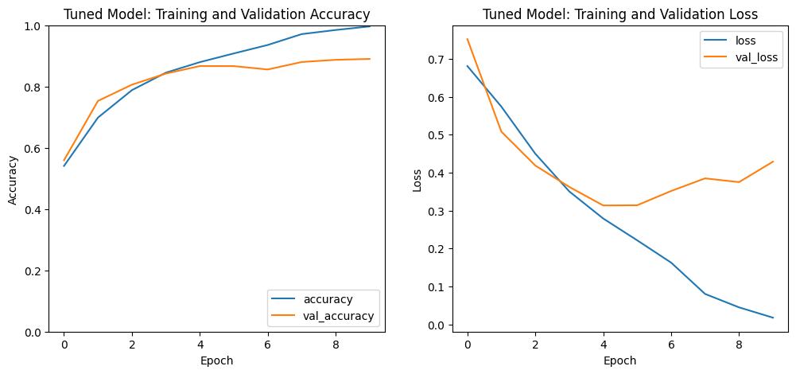
Figure 1. Tuned model (Trial 2) – training vs. validation accuracy and loss over 10 epochs; the epoch-5 weights were restored.
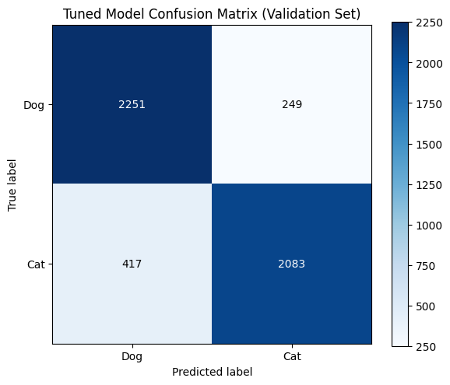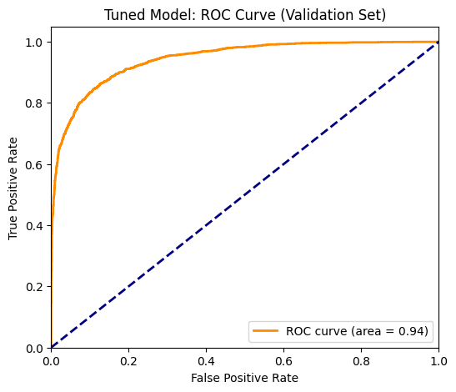
Figure 2 (left). Confusion matrix on the 5,000-image validation set. Figure 3 (right). ROC curve on the validation set, AUC = 0.94.
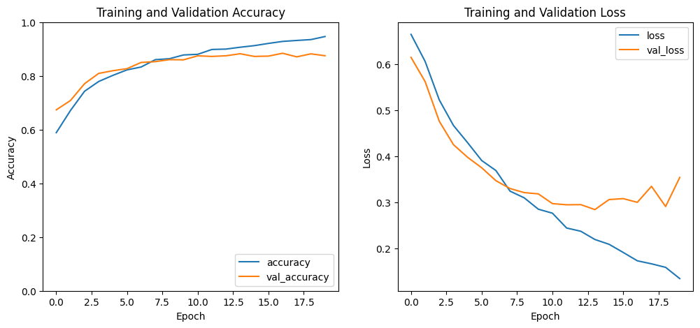
Figure 4. Trial 3 (manual model, 20 epochs) – training vs. validation accuracy and loss.
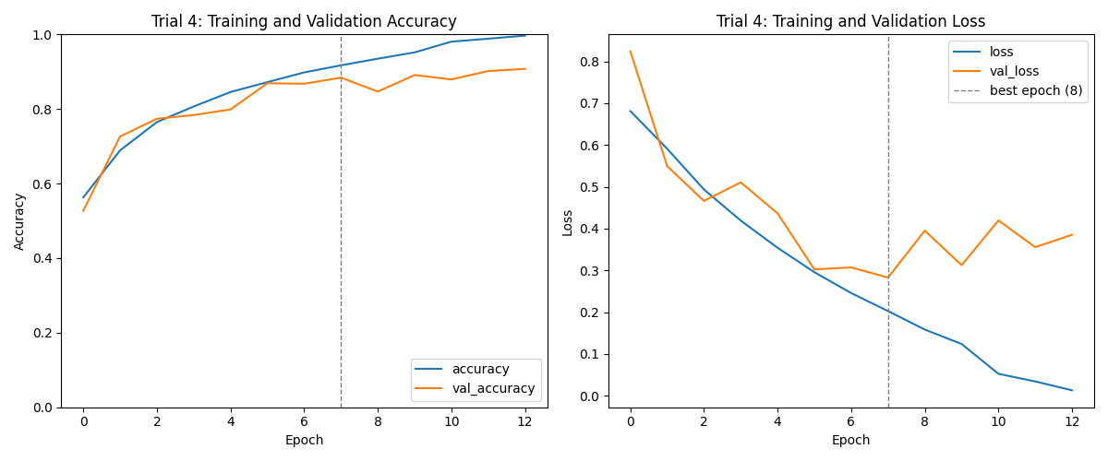
Figure 5. Trial 4 (Keras Tuner, second search) – training vs. validation accuracy and loss over 13 epochs, plotted from the training log; the dashed line marks the restored epoch 8.
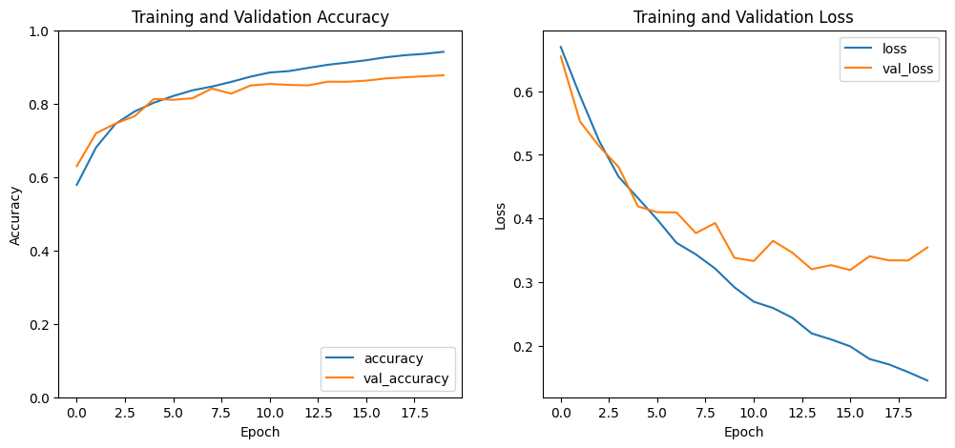
Figure 6. Trial 5 (manual model, 20 epochs, re-run) – training vs. validation accuracy and loss per epoch.
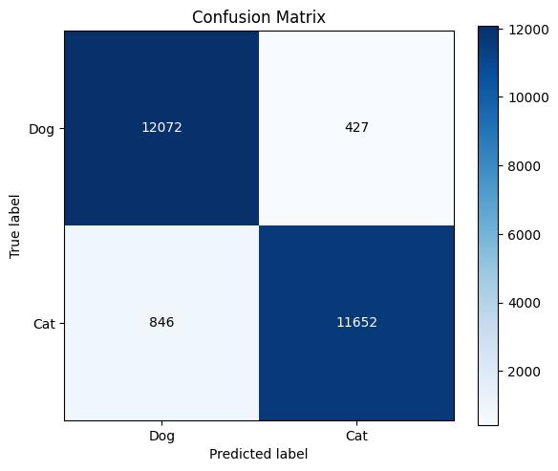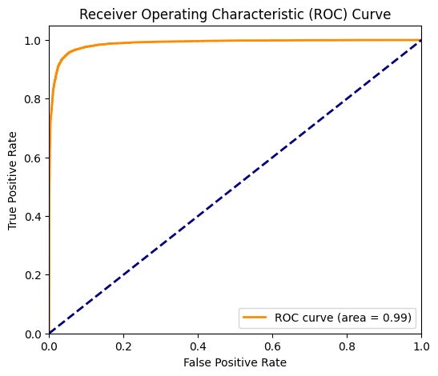
Figure 7 (left). Trial 5 confusion matrix. Figure 8 (right). Trial 5 ROC curve. Both are computed on the full dataset (24,997 images, including training images), so they are optimistic.

6. Overall Justification / Remarks
Summarize why this combination of hyperparameters was chosen (e.g., prior trial results, literature basis, computational constraints) and any observations (overfitting, underfitting, convergence issues).
Trial 1 (manual, 5 epochs). Four conv layers (32/32/64/64 filters, 3×3 kernels), two 64-unit dense layers, dropout 0.3, Adam at 0.0005, batch size 128, trained for 5 epochs on 24,997 grayscale 100×100 images (80/20 split). It ended at 0.8141 training and 0.8152 validation accuracy and was still improving, so the short run limited it.
Trial 2 (Keras Tuner, first search). Hyperband search with 30 trials (up to 20 epochs each, factor 3, 1 h 36 min 16 s, objective = validation accuracy; best search score 0.8854). Best trial #0019: 4 conv blocks (32/96/192/256 filters, kernels 5/3/5/5), two dense layers (160 and 128 units), dropout 0.4, Adam at 0.000425, batch size 64. Retrained with early stopping (patience 5) and a learning-rate scheduler, it reached 0.8668 validation accuracy (AUC 0.9434, epoch-5 weights restored; training stopped at epoch 10). Its precision, recall and F1 are about 0.87.
Trial 3 (manual, 20 epochs). Same settings as Trial 1 except the number of epochs, raised from 5 to 20 (no early stopping). At epoch 20: 0.9464 training and 0.8750 validation accuracy (validation loss 0.3538). Validation accuracy peaked at 0.8842 at epoch 17 and validation loss was lowest at epoch 14 (0.2840). At epoch 5 this run was at 0.8192 validation accuracy, close to Trial 1, so the 6-point gain came from training longer.
Trial 4 (Keras Tuner, second search). The best configuration of a second Hyperband search was retrained with early stopping (patience 5) and the learning-rate scheduler. Its learning rate (0.000293) and batch size (64) differ from the best trial printed in the earlier session (#0013: 0.000118, batch size 32), so it comes from a different search result, and that run’s best-hyperparameters output was not saved: its filters, kernels, dense layers, dropout and optimizer are therefore not recorded in this form. Training stopped at epoch 13; the epoch-8 weights (lowest validation loss, 0.2829) were restored, giving 0.9171 training and 0.8842 validation accuracy.
Trial 5 (manual, 20 epochs, re-run; Loading_Dataset_and_CNN.ipynb). Same architecture and settings as Trials 1 and 3: four conv layers (32/32/64/64 filters, 3×3 kernels, ReLU, 2×2 max-pooling), two 64-unit dense layers, dropout 0.3 after Flatten and after the first dense layer, sigmoid output, binary_crossentropy, Adam at 0.0005, batch size 128, validation_split=0.2, 20 epochs, no early stopping. Training accuracy rose from 0.5786 to 0.9412 and validation accuracy from 0.6300 to 0.8772 (validation loss 0.3544 at epoch 20). The two Dense(64) layers have no activation, so they act as linear layers.
Comparison. On validation accuracy Trial 4 (0.8842) is above Trial 3 (0.8750) and Trial 2 (0.8668), and its lowest validation loss (0.2829) is also the best of the three. The validation sets are not guaranteed to be identical across notebook sessions, so the comparison is approximate, and differences of one or two points may be run-to-run variation. Trial 5 (0.8772, lowest validation loss 0.3190) uses the same configuration as Trial 3 and finished within about 0.2 points of it, so it does not change this ranking and gives a rough idea of run-to-run variation.

